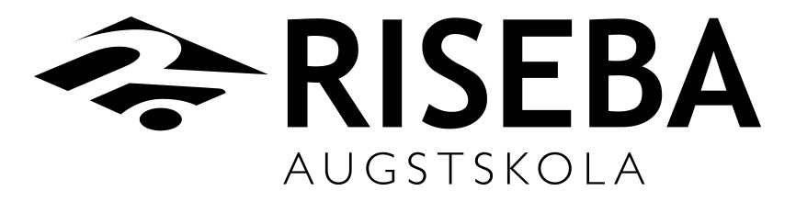
„Study programme”

BACHELOR THESIS

Bachelor Thesis Title
Bachelor Thesis Title in Latvian

Author | student Maris Muiznieks
Scientific Supervisor | Dr.chem., asisstan professor Ilmars Kreituss
Programm director | Mg. oec., Anzelika Smagina
RIGA, 2016

